FINAL PROJECT : Xamarin.Forms Contact Manager App

**Objective**

The objective is to create a new Xamarin.Forms application that applies all the topics covered in the entire Xamarin Masters class. Hence this application **must** implement the use of Data Binding, Listview, Resources and Styles, XAML and REST.

**Project Type**

PCL/.Net Standard

**Grading**

This project has a total score of **100 pts**. Take note that **30%** of your final grade will be coming from here.

**Sample Web API**

<http://10.155.64.110:8080/retrieve/contacts>

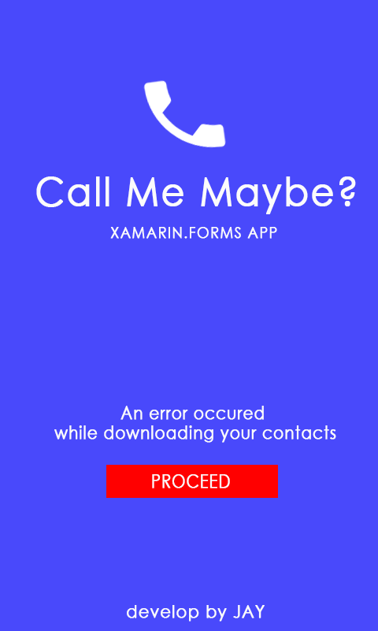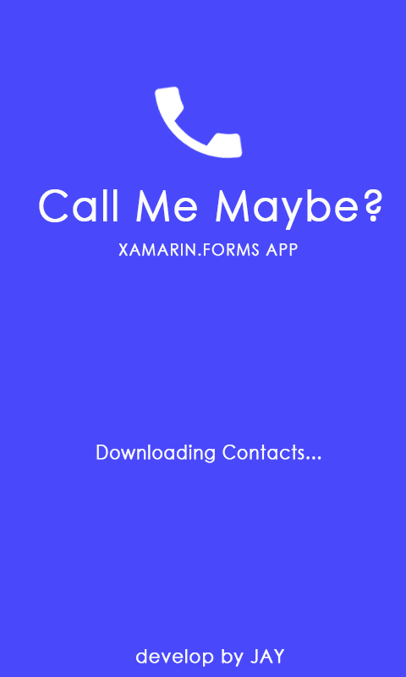**Screens & Scoring**

**Loader Page (20pts)**

This screen should appear after the splash screen.

* It will download a list of contacts from a web service.
* When the app successfully downloads the data, the app should forward to Contacts Page. Contacts Page should display the downloaded contacts.
* The proceed button should appear when the app fails to download the list of contacts
* When the user tapped the proceed button, the app will present the Contacts page showing **empty** list of contacts.

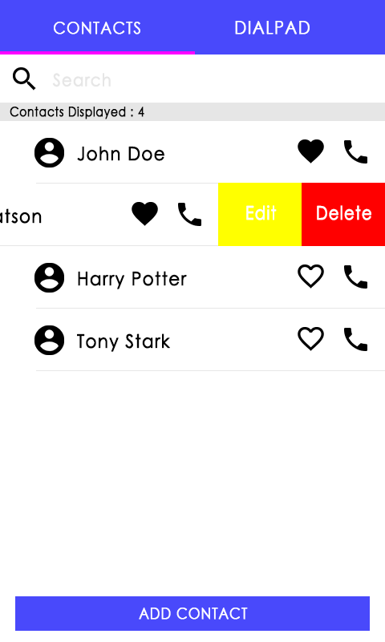**Contacts Page (35pts)**

This is the first tab of our main page. This will display the list of contacts.

* Search Entry should filter the list of contacts based on the text input of the user.
* Contacts Displayed Label represents the total count of the current list of contacts.
* Each row of the ListView represents a contact item.

Heart Button – a toggle button that symbolizes whether a contact is a favorite or not.

Call Button – calls the contact item

There are two Context Actions for each row:

Edit – edits the info of the contact item

Delete – removes the contact item from the list

* + - * Favorite items should be at the top of the list. The app restricts the user to have **10** favorites only.
      * Non-favorite items are displayed at the end of the favorite items and must be in alphabetical order.
      * Add Contact button should present the Add Contact Page.

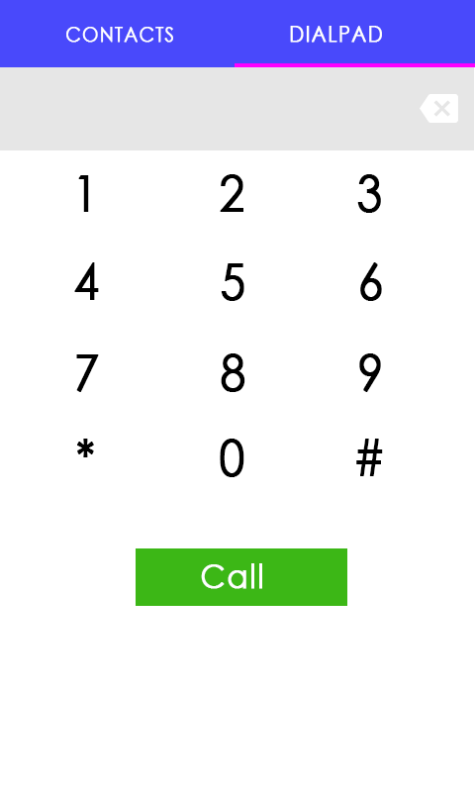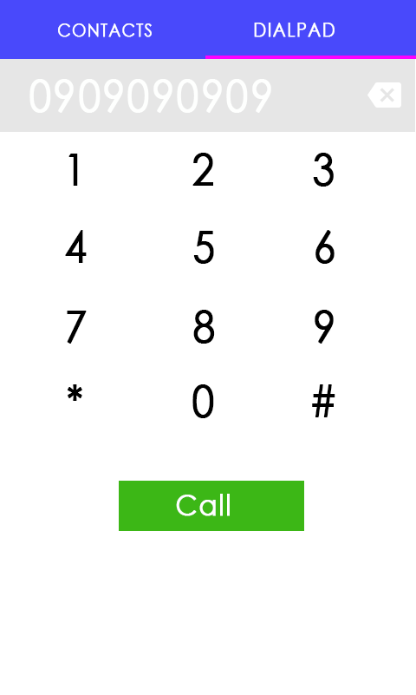

**Dialpad Page (25pts)**

This is the second tab of the main page. It allows the user to dial a phone number.

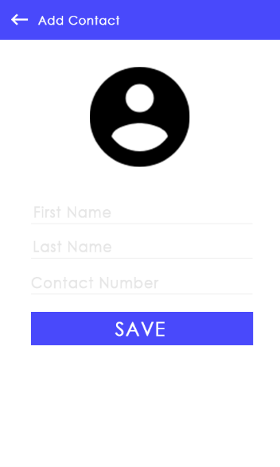**Add Contact Page (20pts)**

This page allows the user to add a contact or update an existing contact.

* Save is the label of the button if the action is to add a contact; Update is the label of the button if the action is to update an existing contact.
* Validation must be observed here. Empty field/s should not execute the add/update function. You may display a toast/ a dialog to notify the user that an entry is invalid.
* Contact Number entry should have a phone number validator.